Heritage Impact Assessment
Site name: Chain Bridge Forge
Address of site: Chain Bridge Forge, High St, Spalding, Lincs. PE111TX
Schedule of Work:
The project will create a new eco friendly 2 storey Blacksmith workshop that will be adjacent to the existing building. The building will be styled on Birches Black Granary that sat on the river bank a further 100m south of the Forge until 1960’s. The need for the project is that the ability to buy and burn fossil fuels will become severely restricted. Suppliers of fossil fuels are already contacting us indicating severe restrictions and the possibility of no mines being available in the uk. Suppliers are indicating that this may mean the fuel needs to be imported from Russia.
Proposal: New build using recycled shipping containers and clad with weatherboard to replicate the Birches Black Granary. It will also use solar power to generate electricity.

2. Pre Application Advice
Permission to remove trees has been granted subject to satisfactory planning proposal. The Forge and the Architect have discussed the project with the SHDC. Conservation Officer based on initial sketches produced.

3. What heritage asset(s), including their setting, are potentially affected by the proposals?
New build in the Conservation Area using recycled materials where possible and using alternative energy sources to minimise costs.

4. What is known about the affected heritage asset(s)?
History of Chain Bridge Forge
The Forge has its origins in the late 1700’s and is constructed using local bricks and a roof using pan tiles. In 2011 an archeological survey was completed and the report can be found at
https://www.heritagesouthholland.co.uk/wp-content/uploads/2014/10/SPCB11-Complete-Report1.pdf

The first blacksmith we have found operating the Forge was Joseph Rose. The Rose family lived opposite the Forge and the brothers had a number of occupations around the town (Grocer and Ironmonger). The Forge must have been extremely busy looking after the needs of the Port of Spalding, Farmers, trades people and the community. The Mr Fixit of his day. On his death in 1814 the Forge used by Francis South and by 1850 the ownership had moved to Edward Fisher. Edward worked the Forge until his death in 1898.
The Forge then moved to the ownership of the Dodd family and in total 3 generations used it to earn their living.
George Robert Dodd the first generation came from South Kyme where his father was a farmer. The farm wasn’t large enough to support the family and Joseph became a blacksmith apprentice in Swineshead. He completed his apprenticeship and then moved to Newmarket to continue his work and also found his wife. Interestingly he was able to use RSS (Registered Shoe Smith) after his name and signified his skill with horses. Possibly this was the start of the Blacksmith and Farrier crafts diverging. George must have been well regarded as in the 1920’s he becomes the Harbour Master for the Port of Spalding. His duties would have been to ensure the river was navigable and he also had the key which operated the swing bridge at the Forge. He was paid £5 per year for this and a further shilling for every boat that went through the bridge.
George’s son, James, (known as Jim or Banks Dodd) followed in his father’s tradition.
The final Dodd to own the Forge was Geoffrey Dodd. He took over in the 1950’s and the business was in decline as the need for blacksmiths was waning. Mechanisation on farms had resulted in a different set of skills which didn’t suit the Blacksmith skills. However for Geoff Dodd the salvation came from the starting of Spalding Flower Parade in 1958 and for the next 50 years he built most of the Flower Parade floats.
In 1989 Geoff sold the Forge to the Council for £1 so that it could be retained for future generations.
The Friends of Chain Bridge Forge took a 25year lease from the Council in 2010 with the objective of conserving the forge, its artefacts and telling the story of this historic building while continue the trade of Blacksmithing and sharing this knowledge with the community.
The Forge uses two websites to tell stories and communicate with the community and visitors.
Www.chainbridgeforge.co.uk
Www.heritagesouthholland.co.uk

Forge in 1970’s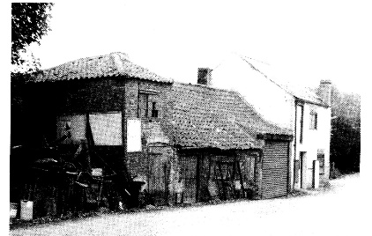
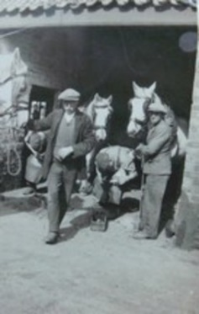  Shoeing Horses in the Shoeing Shed 1940 | 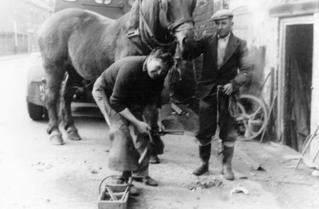  Geoff Dodd Shoeing a horse in circ. 1950's
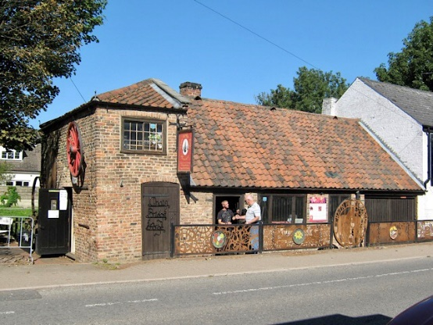 The Forge as it is in 2022
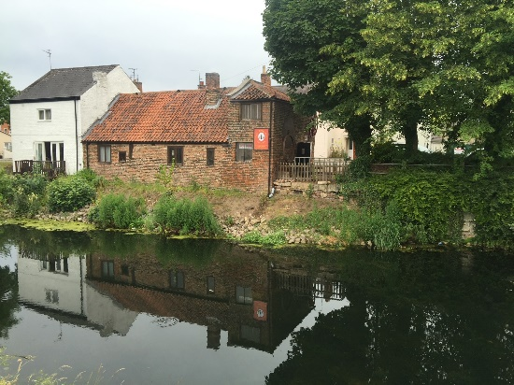
Forge from the River Welland

4 (b) What research have you undertaken to understand the significance of the heritage asset(s) affected?
Information held by Chain Bridge Forge in their archive.

5. What is important about the affected heritage asset(s) (‘the significance’)?
The building and its significance
The building is thought to date from the late 1700s and was a purpose built blacksmith’s workshop. It is situated on the east bank of the River Welland about one mile from the town centre, only four metres away from the river itself. It has not been listed by English Heritage, but is a building of historic interest and is located within the town’s conservation area.
The Forge has three section, the largest of which contains the hearth/forge and is the main workspace, to the right the Shoeing shed and the area to the left which was the old store. This store has two floors the downstairs area has a library and information boards. Upstairs is our Innovation area. The original floor is mainly of hard packed earth, with large pieces of stone and slate covering some areas. Today this is covered by a wood floor which allows wheelchair access.
The Forge is approximately 12m 35cms long and 6m 35cms wide.
The white building on the right was used by a sail maker.
The Collection
This is a collection of tools and equipment that were used by the Blacksmith. The collection covers items which were used through the Forge’s life. The collection can be found at
https://ehive.com/objects?query=chain+bridge+forge
The Craft of Blacksmithing
The Forge employs a trained Blacksmith who continues the traditional role of the Blacksmith conducting restoration, repairs, commissions and also provides expert training and tasters.
Connection to the Local Community
In the early days of the museum it became apparent visitors enjoyed sharing their memories of Blacksmithing and the community it served. The Forge have created a library of resources and transcribed much of this information to an online website. www.heritagesouthholland.co.uk
The website now has 16000 items which are visited by the community on a daily basis.

6. How will the proposals impact on the significance of the heritage asset(s) and their setting?
The proposed location of the new building sits on the riverbank 5m to the south of the Forge. The 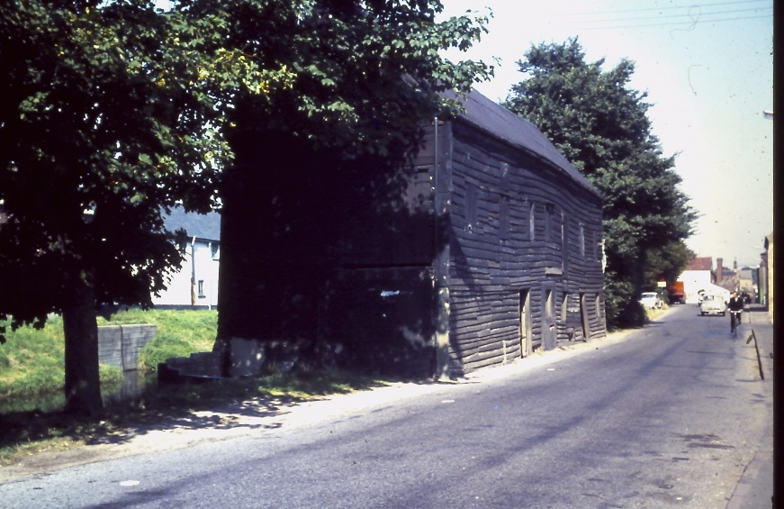
land has no designated purpose, poorly maintained and currently has a combination of trees and shrubs. The Tree Conservation Officer for the Council has given her blessing to remove 3 trees to enable construction. This land is within the conservation area and the Forge will seek to develop a sympathetic solution which replicates Birches Black Barn (photo above).
More Photos can be found at
https://www.heritagesouthholland.co.uk/article/photographs-of-the-black-barn/

We would recommend an archaeology watching brief as when the base is laid there maybe potential evidence of the footings of the original Chain Bridge which was removed in 1844 but its precise location isn’t known.

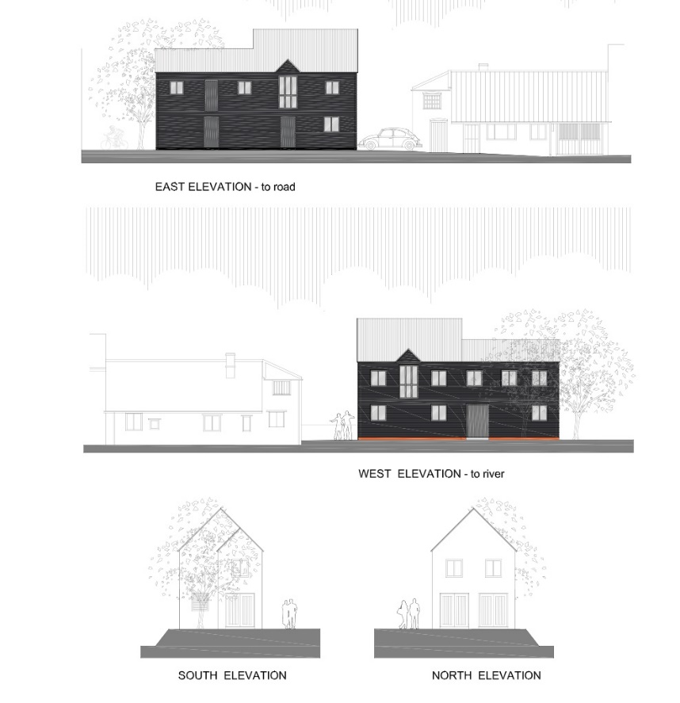

7. How has the proposal been designed to conserve the significance of the heritage asset(s) and their setting?
This project will deliver sustainability to the Forge ensuring if fossil fuels become unattainable then we will still be able to preserve the Blacksmith craft and offer services to our customers.

