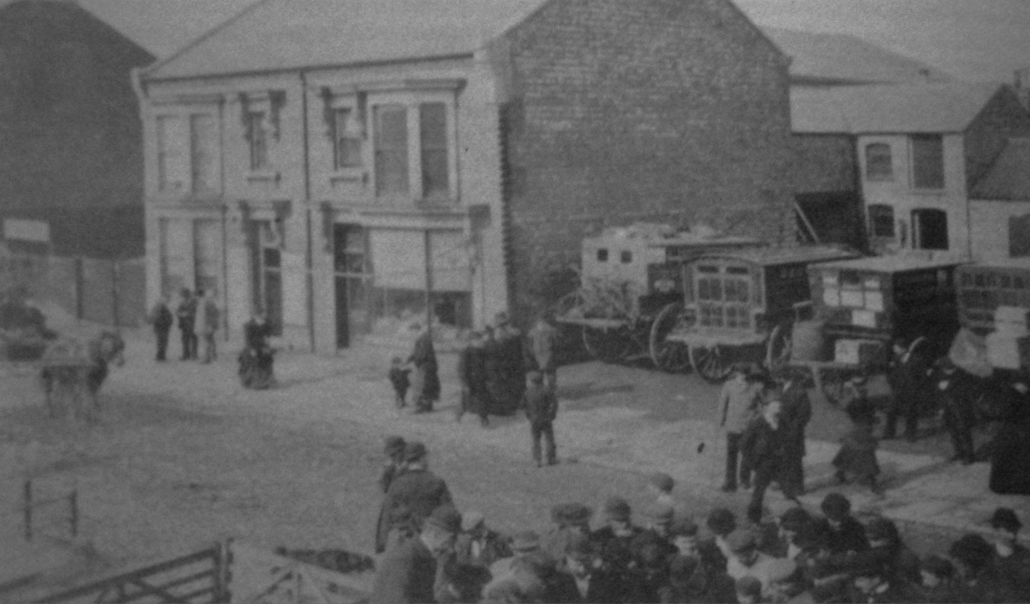

Carrier Carts From Spalding

1868
DESTINATION CARRIERS

Billingboro - Pickworth, from' Pied Calf,' Tuesday

Bourne - Carter, from 'Pied Calf,' Tuesday & Saturday

Crowland - Everitt, from ' White Horse,' Tuesday, A. Blood, from 'Bull,' Tuesday;
Frisby, from 'New Bell, Tuesday & Friday

Deeping Gate - T. Hyde, from' White Hart,' Tuesday

Donington - Sutherill, from 'Cross Key’ Tuesday,
Barnsdall, from 'Black Swan,' daily, except Monday & Wednesday

Gedney hill - Jackson, from 'Bull,' Tuesday; T.Clark, from 'White Horse,' Tuesday

Gosberton - Rutkin, from' Red Lion,' Tuesday

Gosberton Risegate - Pointon, from 'Cross Keys, Tuesday

Gosberton Westhorpe - Mrs Fairbanks, from' White Hart,' Tuesday

Holbeach - John Cotton, from' Chequers,' Bourne Road, each week day excepting Tuesday

Langtoft - Walling, from' Old Bell,' Tuesday

Long Sutton - Piccaver, from, 'Old Bell,' Tuesday

Market Deeping - Woods, from' New Bell,' Tuesday

Pinchbeck Bars - Porter, from' Pied Calf,' Tuesday

Pinchbeck West - Risely, from' Great Northern,' Tuesday

Sutterton - ------? from 'Red Lion,' Tuesday

Sutton St. Edmunds - Thompson, from 'Bull,' Tuesday

Sutton St James - Keach, from' White Horse,' Tuesday

Whaplode Drove - Waterfall, from 'New Bell,' Tuesday, Spriggs, from ' New Bell,' Tuesday;
Richards, from' Ram Skin,' Tuesday

Railway Carriers .- Sutton & Co. parcels only;
J.Harris, agent, Market place

1885

Bourne - Tipler, 'Pied Calf,' Tuesday ; Bennett, Thursday

Crowland -- Everitt, 'White Horse,' Tuesday. ; Pepper, 'Lincoln Arms,' Tuesday.;
Frisby, ' New Bell,' Tuesday. & Friday
Donington - Richman, 'Red Lion,' Tuesday. & Saturday

Gosberton - Holden, ' Cross Keys,' Tuesday. ; Priestly, 'Red Lion,' Tuesday

Gosberton Westhorpe - Sewell, 'Cross Keys,' Tuesday

Holbeach Bank - Fenn, ' White Horse,' Tuesday

Langtoft - Welling, 'New Bell,' Tuesday

Long Sutton - Whitelam, 'Lincoln Arms,' Tuesday

Market Deeping - Smith, 'New Bell,' Tuesday

Moulton Seas End - Thompson, 'White Horse,' Tuesday

Pinchbeck - Roberts, 'Pied Calf,' Tuesday

Pinchbeck West - Riseley, 'Great Northern,' Tuesday & Saturday
Bean, ' Greyhound,' Tuesday & Saturday

Sutton St. James - Scrimshaw, 'Bull,' Tuesdays

Whaplode Drove - Bailey, 'Bull,' Tuesday ; Hatter, 'Ramskin,' Tuesday.; Cooper, 'Lincoln Arms' ---?

Railway Carriers .- Sutton & Co. parcels only; J. R. Measures, agent, Butter market

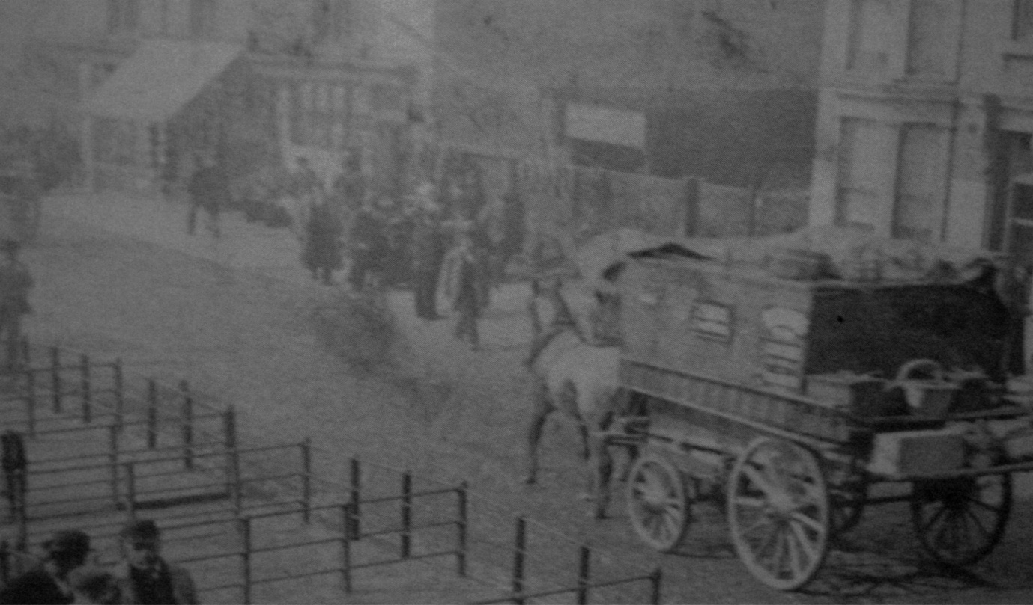

1905

Bourne - Reynolds, ' Pied Calf,' Tuesday

Crowland - Everett, 'White Horse,' Tuesday. ; Bailey, 'White Lion,' Tuesday
Frisby, 'New Bell,' Tuesday.& Friday

Donington - Hempsall, 'Red Lion,' Tuesday & Saturday

Fosdyke - Fenn, 'Ramskin,' Tuesday. 'White Horse,' Tuesday

Gedney Hill - Snelling, 'Little Bull,' Tuesday

Holbeach Drove - Hatter, 'Ramskin,' Tuesday

Langtoft -- Frisby, 'New Bell,' tues

Long Sutton - Whitelamb, 'Lincoln Arms,' Tuesday

Market Deeping - Milbourn, 'New Bell,' Tuesday

Pinchbeck West .- Dance, 'Greyhound,' Tuesday, Thursday.& Saturday. ;
Miller, 'Pied Calf,' Tuesday. Wednesday. & Saturday. ;
Gedney ‘ Pied Calf,' Tuesday Rouse, 'Pied Calf,' Wednesday. & Saturday

Sutton St. James - Scrimshaw, 'Little Bull,' Tuesday

Whaplode Drove - Hatter, 'Ramskin,' Tuesday. ; Rose, 1 Lincoln Arms,' Tuesday

Railway Carriers .- Sutton & Co. parcels only; Walden & Sons, agents, 1a, London road

W Hatter who was carrier to Whaplode Drove
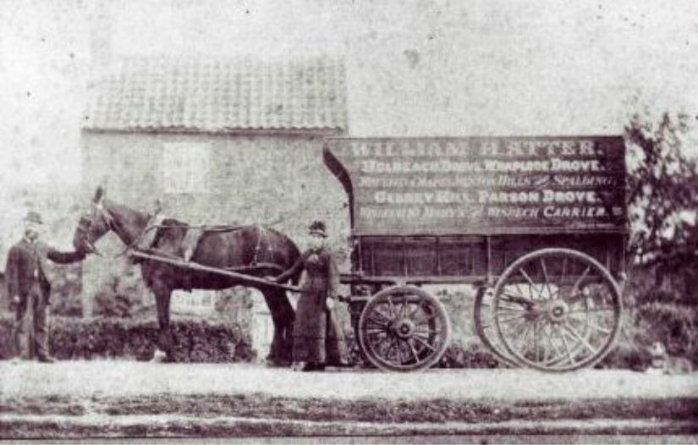

1919

Crowland - Everett, ‘White Horse’ Tuesdays; Frisby, ‘New Bell’ Tuesday and Friday
Madison, ‘Little Bull’ Tuesday

Donington - Hempsall, ‘Red Lion’ Tuesday and Saturday

Fosdyke - Machin, ’White Horse’ Tuesday

Gedney Hill - Mackman, ’Lincoln Arms’ Tuesday

Langtoft - Plowright, ’Little Bull Tuesday

Long Sutton - Vickers, ‘Lincoln Arms’ Tuesday

Market Deeping - Andrews, ‘New Bell’ Tuesday; Plowright,’Little Bull’ Tuesday

Pinchbeck West - Dance, ’Greyhound’ Tuesday, Thursday & Saturday
Gray, ’Pied Calf’ Tuesday, Wednesday & Saturday
Moon, ‘Pied Calf’ Tuesday & Saturday;
Dawson, ‘Pied Calf’ Tuesday, Wednesday & Saturday

Saracens Head - Elsey, ‘White Lion’ Tuesday; Andrews, ‘New Bell’ Tuesday

Sutton St James - Scrimshaw, ‘Little Bull’ Tuesday

Whaplode Drove - Seaton, ‘Ramskin’ Tuesday; Mackman, ‘Lincoln Arms’ Tuesday

