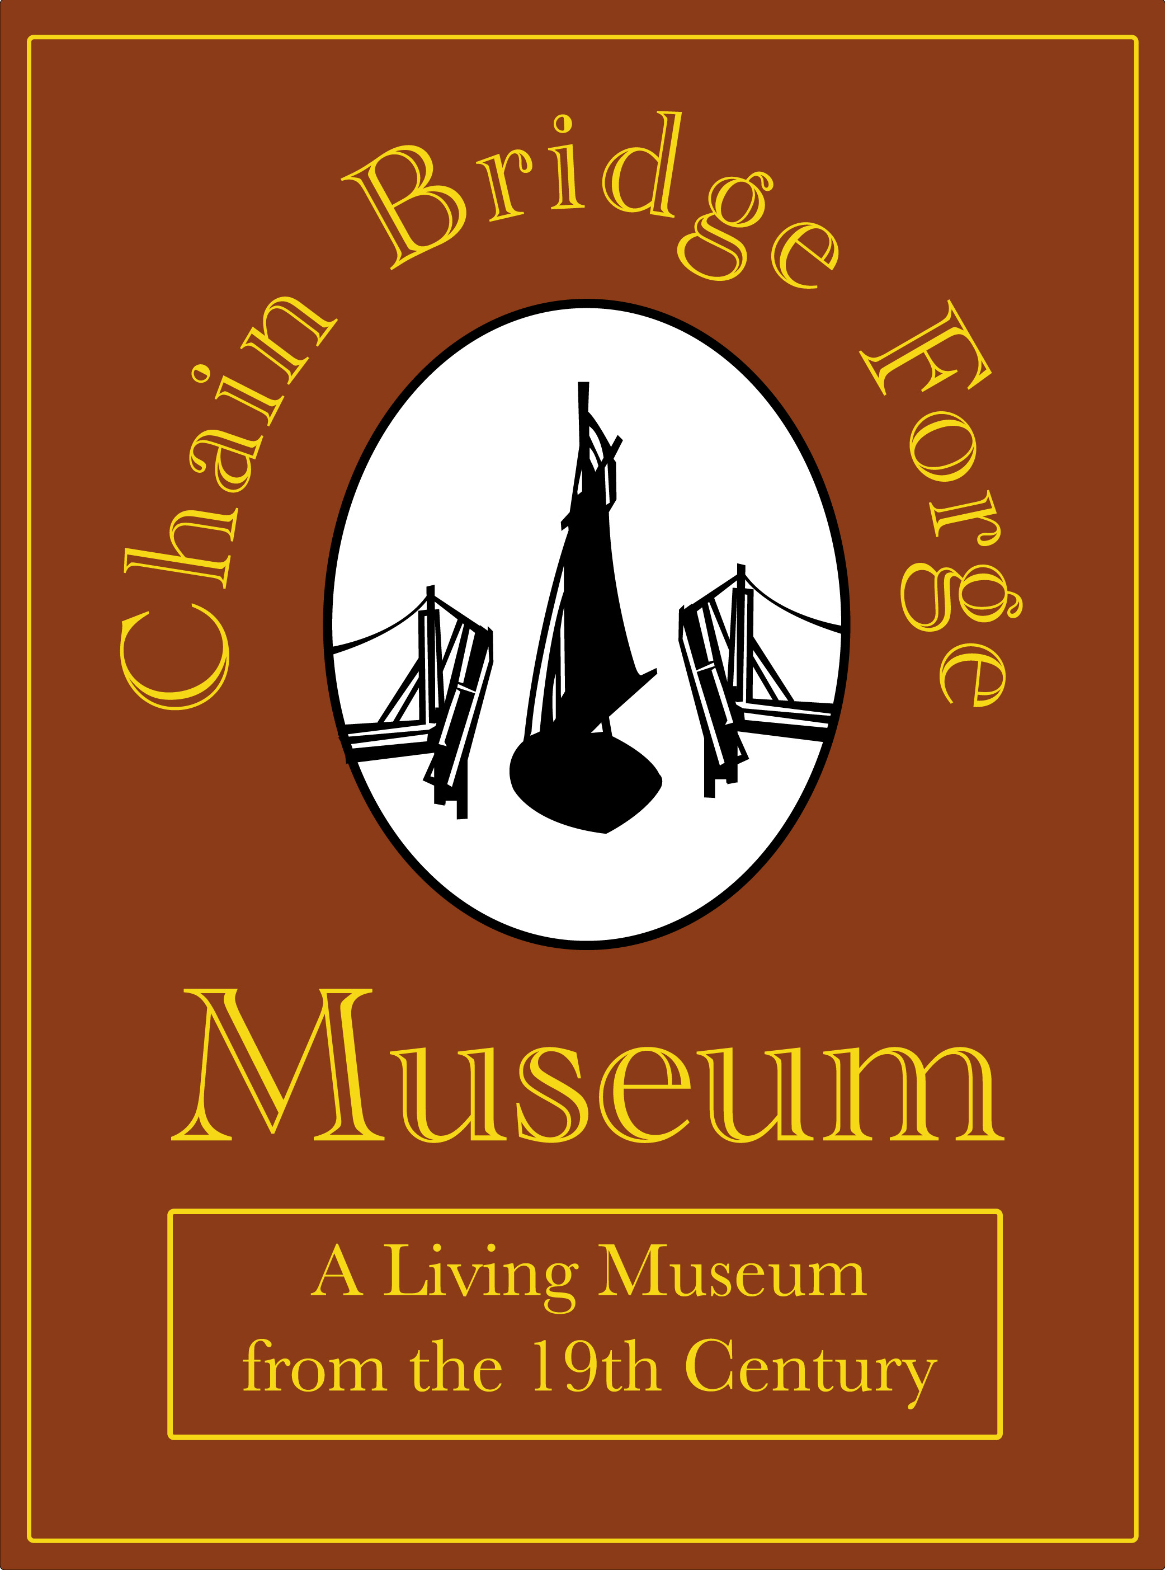
The Friends of Chain Bridge Forge
Social Media Policy

Prepared By: | Geoff Taylor
Business Name: | The Friends of Chain Bridge Forge
Address: | Site Address:  High Street  Spalding  Lincolnshire  PE11 1TX | Postal Address:  107 Hawthorn Bank  Spalding  Lincolnshire  PE11 1JQ
Tel. Number: | 07960 587724
E-mail  Website | chainbridgeforge@googlemail.com  www.chainbridgeforge.co.uk  and  www.southhollandlife.com

As part of the team at Chain Bridge Forge we are all ambassadors for the Forge and as more of us use social media sites like Facebook, Twitter, Flickr, YouTube, Forge Websites to keep in touch with friends or colleagues and also communicating with the community.
Taking part in social media offers great benefits to us as individuals but as we build an online community it also offers the opportunity to communicate with the community and potential visitors.
The best advice is to approach the online world in the same way we do the physical one – by using sound judgement and common sense.
Be true
Treat people with respect and avoid speaking negatively about other people, companies or organisations.
Be authentic
Identify yourself as linked to the Forge as either Chain Bridge Forge or South Holland Life. Always state that ‘All views are my own’ in your profile. Don’t use an alias or mislead people about your connection with the Forge.
Be aware
Remember that everything on the Internet is public and the community will have access to the content or images you post online and information originally intended for friends and family can be passed on and traced back. Always assume that all your social media communication is visible to everyone, anywhere.
Be mindful that media and community are watching
The media and community are constantly searching the internet for information about the Forge or South Holland Life. Help us to protect our creativity and integrity by thinking carefully about the content you share online. If you see something that needs attention or requires a response, please share it with a Director.
Think
Be responsible
How can you help? You are responsible for what you write and you should stick to what you know. Comments, posts and images are public and permanent, even with privacy settings in place. Try to ensure your posts are accurate, not misleading or damaging. If you’re not sure, don’t post it. As in the ‘real’ world any inappropriate comments maybe liable.
Always protect Forge information
Be careful not to reveal sensitive or confidential information about the Forge, plans, colleagues or customers. If you see any derogatory information posted in a public forum, inform a Director.
Think before you post!
Acknowledge
Respect
- Copyright – Normally taken to be if an artefact is less than 70 years old or if a statement is published stating a restriction of use. Gain approval to publish or Credit where it is due. Don’t post text, images or videos that were created by someone else without crediting them. (Where known) Where possible include a link to the source.
- Title – If there is watermark, statement or restriction of use don’t publish without gaining approval.
- Oral Histories – ensure appropriate approval have been given and are recognised
- Publication and Video which have been produced for sale or publication ensure approval is in place for content as needed.
Complaints
If a complaint is received the following process must be applied.
- Inform the Directors
- Acknowledge the complaint
- Remove offending content until resolution can be achieved
- Arbitrate
Insurance
Send to insurer after we agree the content and ask for comment and cover offered within the existing policy.

