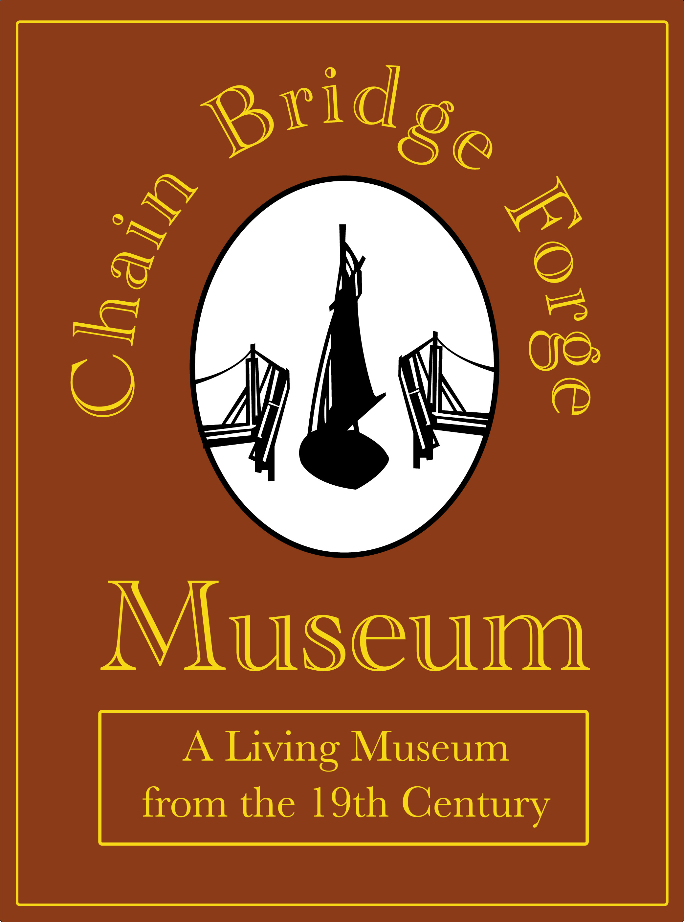
Chain Bridge Forge
Access Policy Statement

Prepared By: | Geoff Taylor
Business Name: | The Friends of Chain Bridge Forge
Address: | Site Address:  High Street  Spalding  Lincolnshire  PE11 1TX | Postal Address:  107 Hawthorn Bank  Spalding  Lincolnshire  PE11 1JQ
Tel. Number: | 07960 587724
E-mail  Website | geofftaylor1946@googlemail.com  http//:www.chainbridgeforge.co.uk
Approved by | Directors Meeting, 26th Jun 2013
Date for review | June 2018

1. Vision
Chain Bridge Forge Museum will be a living museum, which tells the story of the Blacksmith’s Workshop, the people involved the Blacksmith’s craft, and their relationship to the community that they served.
2. Our definition of access
We define access as something that is made possible when physical, cultural, social, financial, intellectual, psychological and emotional barriers are removed, reduced, or overcome.
3. Our commitment to accessibility
3.1 The Friends of Chain Bridge Forge are committed to providing the widest possible access to their Museum, collections and services to enable audiences from all sections of the community to enjoy the use of the Museum. Our policy is to build accessibility into everything that we do to develop and improve our services. This commitment is long term and our aim is to make continuous improvements as our resources permit. This commitment extends to our workforce as well as visitors. We are committed to providing our workforce with ongoing training in access issues.
3.2 Our policy is to build accessibility into everything that we do to develop and improve the museum. In order to eliminate barriers to access we will consider the following forms of accessibility:
- Physical: to enable people with physical disabilities to reach the public areas of the Museum and appreciate every part of it. This includes the needs of the elderly and of people caring for young children.
- Sensory: to enable those with impaired vision or hearing to enjoy and appreciate the museum’s building, exhibitions and collections.
- Intellectual: to enable people with learning disabilities to engage with and enjoy the museum and its collections. We also recognise that people have different learning modes and will provide interpretation in a range of learning styles.
- Cultural: to enable those for whom English is not a first language, or whose knowledge of English history and culture may be limited.
- Emotional and attitudinal: to ensure that the museum environment and workforce are welcoming to visitors from all sections of the community.
- Outreach: to connect with external groupings ie Schools other Heritage attractions to deliver an awareness of Blacksmithing remote from the Forge.
- Virtual: to make available on line the catalogue of the forge and the collection of Forge artefacts, community documents, photos and oral histories
- Financial: the Friends of Chain Bridge Forge are committed to free admission for all its visitors.
3.3 We pay due regard to intergenerational equality. The rights of future generations to enjoy access to our present collection are safeguarded by high standards of collection care and where necessary by restrictions on handling, or exposure to light, moisture or other harmful environmental conditions.
3.5 The museum’s website is fully accessible to disabled people including those who may be using it with the help of special equipment.
3.6 The museum is open to the public on regular basis as specified at http://www.chainbridgeforge.co.uk and a notice displayed on the door.

